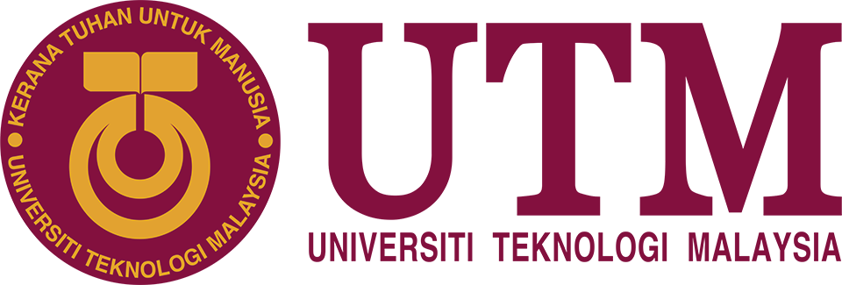

Technopreneurship Seminar Final Report
FACULTY OF COMPUTING
2024/2025 SEMESTER 2 SECD3761
TECHNOPRENEURSHIP SEMINAR
SEMINAR TITLE:
DATE & TIME: 26 June 2024, 8:00 AM- 5:00 PM
LECTURER’S NAME: DR RAMESH K S @ MOHD ZAIDI BIN ABD ROZAN

SECTION: 01
GROUP: 27

No | Name | Matric No
1. | MOHAMED ALIF FATHI BIN ABDUL LATIF | A23CS0112
2. | IMAN ABADI BIN MOHD NIZWAN | A23CS0084
3. | MUHAMMAD AFIQ DANIAL BIN ROZAIDIE | A23CS0117
4. | DHESHIEGHAN A/L SARAVANA MOORTHY | A23CS0072
5. | PRAVINRAJ A/L SIVABATHI | A23CS0171
6. | ESED NADI EYYUBIOGLU | A22EC4029

Intro:
SKUDAI, June 2025 — The Faculty of Computing Research and Innovation (FCRI) day emerged as a significant event, drawing industry professionals, technology enthusiasts, and curious minds to explore the fusion of Cloud Computing, Network Telecommunication, Human Resources exposure, and Artificial Intelligence. Hosted at N28A, Faculty of Computing, Universiti Teknologi Malaysia (UTM) on June 26, 2025, the seminar featured engaging sessions, exciting showcases, and a delightful array of food trucks. Participants had the opportunity to hear from professional speakers, explore booths showcasing the latest AI technologies, Network Telecommunication, Information and Communications Technologies (ICT), and also enjoy a variety of delicious treats.

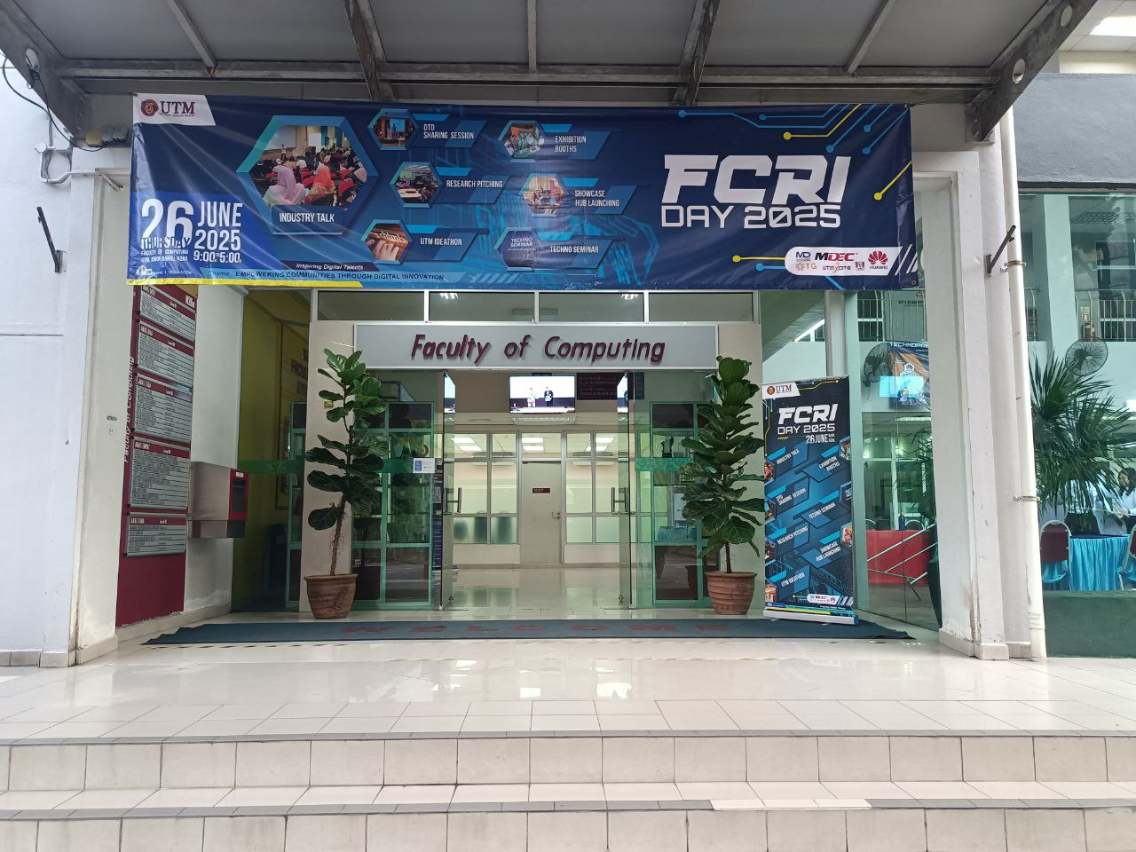
FCRI event during June 26, 2025 in N28a Faculty of Computing

Objective:

The primary objectives of FCRI Day were to bring together industry professionals, tech enthusiasts, and students to explore the latest innovations in Cloud Computing, Network Telecommunication, Human Resources exposure, and Artificial Intelligence. Through professional talks and interactive exhibitions, participants gained valuable insights into the integration of these technologies, particularly how AI is shaping the future of ICT and network communication. The event served as a dynamic platform for learning, networking, and experiencing firsthand the real-world impact of advancing technologies.

Seminar Highlight:

One of the standout moments of the Technopreneurship Seminar was the dynamic panel discussion featuring renowned industry experts: Mr. Louis Chee, Head of Business Development at AI Nusantara; Mr. Wesley Chong Kwai Yong from BNext Solutions; Nur Arina Binti Ramlee of CyberSolution Technologies; and Dr. Lau Cher Han, representing LEAD. Held at Dewan Kejora, N28a, the discussion delved into emerging technologies such as stable diffusion, examining their transformative impact on content creation across industries. Each speaker brought a unique perspective on how artificial intelligence is reshaping creative workflows, generating original content, and pushing the boundaries of what’s possible in digital storytelling. The session left the audience with deep insights into current tech trends and practical examples of how AI is being used to drive innovation, inspiring students to think creatively and embrace technological change in their future careers.

Adding to the vibrant energy of the event were the Exhibition Booths, which created an engaging and interactive atmosphere throughout the faculty building. Leading companies including Huawei, DF Automation & Robotics, Nexscholar, and other forward-thinking organizations showcased their latest technological advancements through hands-on, live demonstrations. These booths allowed students to explore cutting-edge developments in areas such as automation, cloud computing, and embedded systems, offering a real glimpse into the tools and platforms shaping the tech landscape. More than just tech demos, the booths functioned as valuable networking hubs, giving students the opportunity to connect with professionals, ask about career pathways, and even discover internship or collaboration opportunities. This industry showcase, while compact, delivered a strong message about the importance of bridging the gap between academic learning and industrial innovation, reinforcing how collaboration between universities and companies can help drive Malaysia’s digital economy forward.
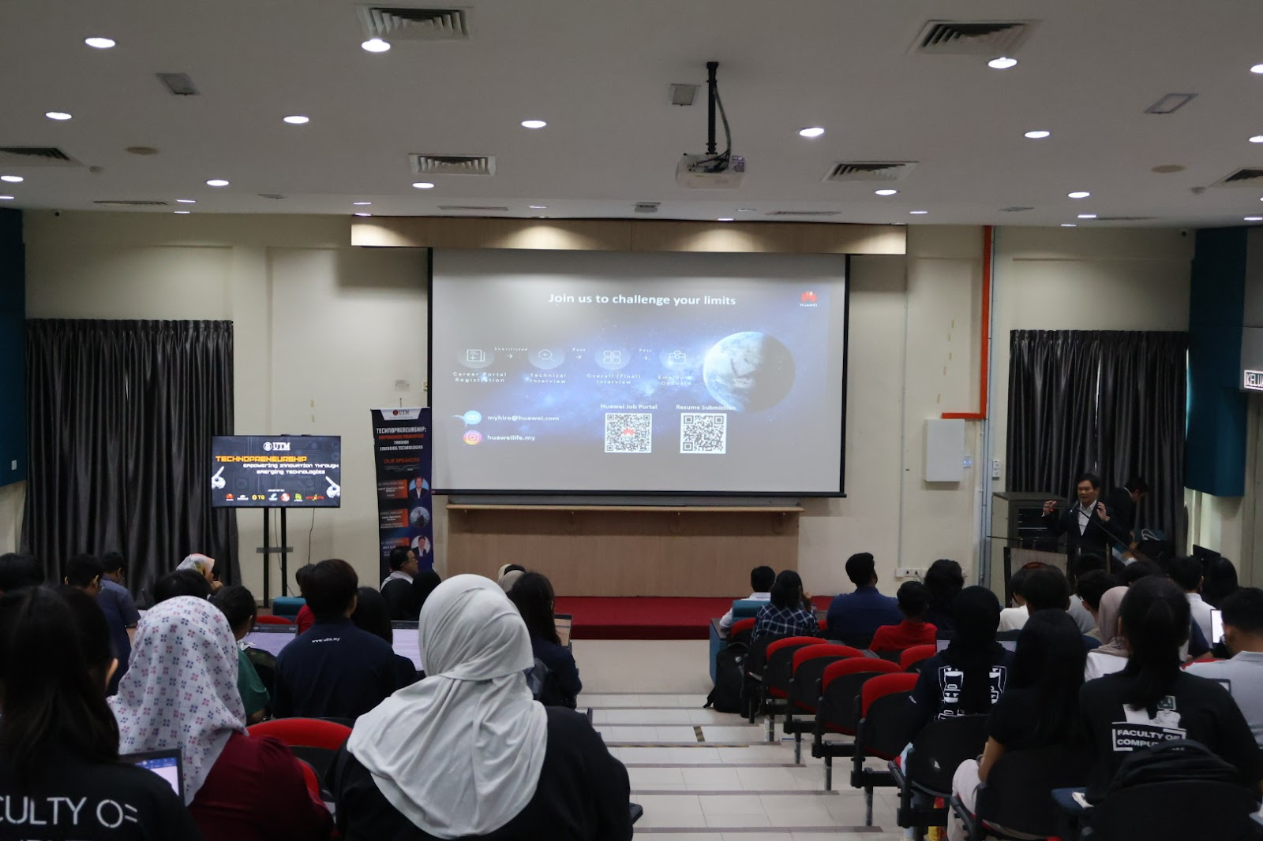
Seminar happening in Dewan Kejora, N28a

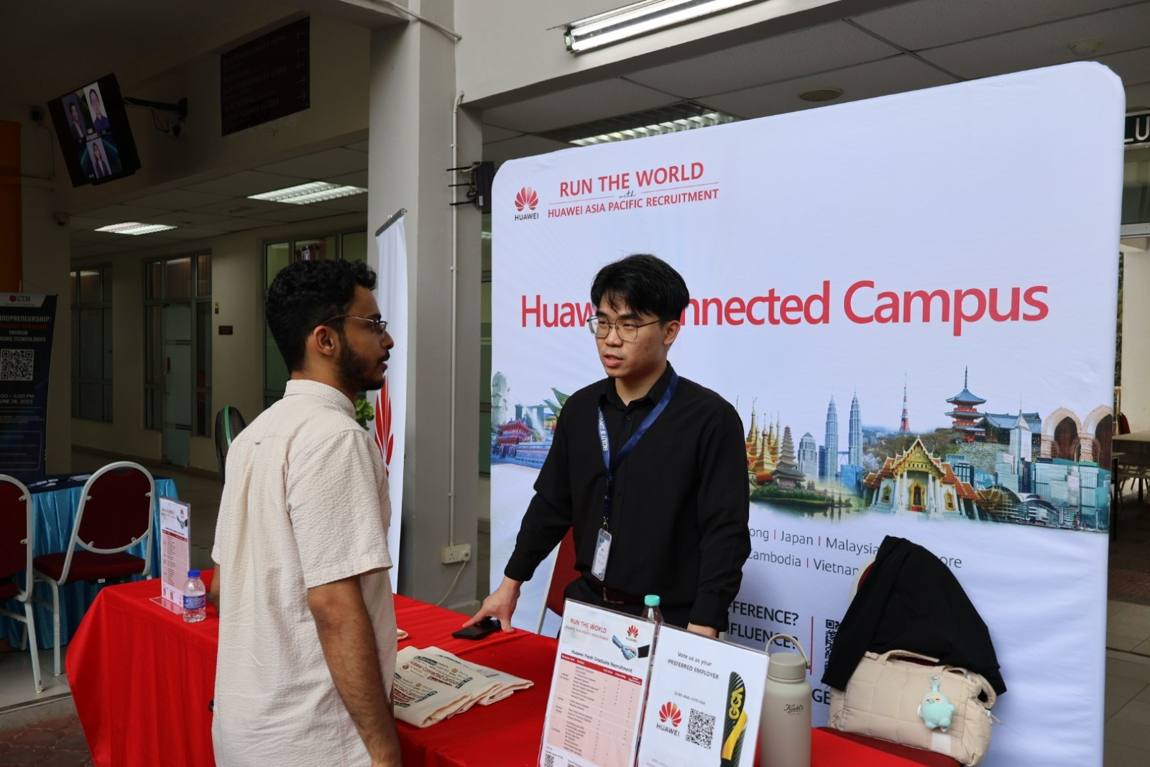
Huawei Exhibition Booth

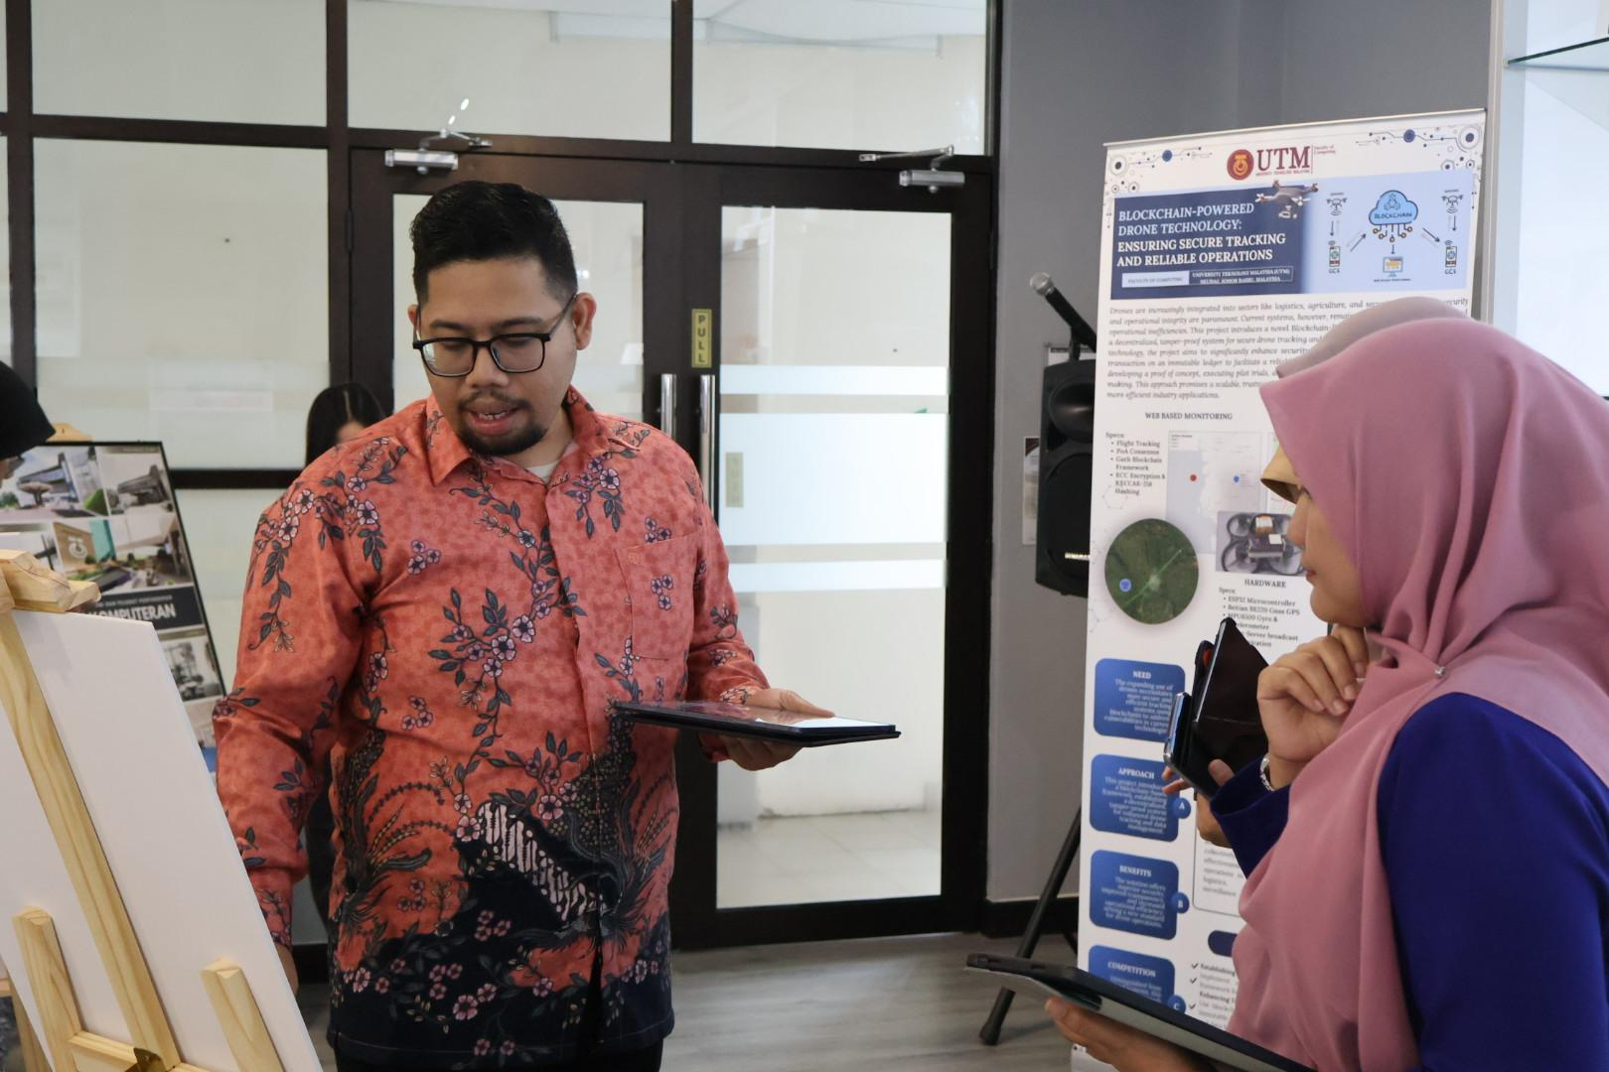

Dv

Automation and Embedded systems showcase

Showcase Highlight:
The event featured several showcases. Nexscholar demonstrated their research website, which allows students to search for the most suitable projects that match their needs using AI. Lattel Robotics showcased their robot, named Jupyter Robot, which is capable of autonomous navigation, visual perception, speech interaction, mobile manipulation, and utilizes AI, machine learning, and cloud computing. Both TG Group (“TG”), a workforce solutions provider that adopts a future-centric approach, providing talent solutions for the digital world, and Huawei, a leading global provider of information and communications technology (ICT) infrastructure and smart devices, showcase job opportunities under their respective companies, offering various job positions, each highlighting different requirements and key responsibilities. This can be served as an insight for students about their desired job so that they can prepare themselves for it. Cyberport Academy, a business unit of MSC Cyberport Sdn. Bhd. is a certified training provider specializing in digital skills certification training in Malaysia committed to supporting the national agenda in Malaysia, assisting individuals and companies in adopting Industry 4.0 and embarking on the industrial revolution. RunCloud also has a training program named RunCloud Education, which specializes in cloud computing, web application deployment to the cloud, and understanding cloud services with digital certificates included.
The showcases gave participants a better understanding of how AI and digital technology are used in different industries. They learned about job opportunities, the skills needed for future careers, and available training programs. The event also shared useful information on the latest tech trends, funding options for AI projects, and how to prepare for the digital workforce.
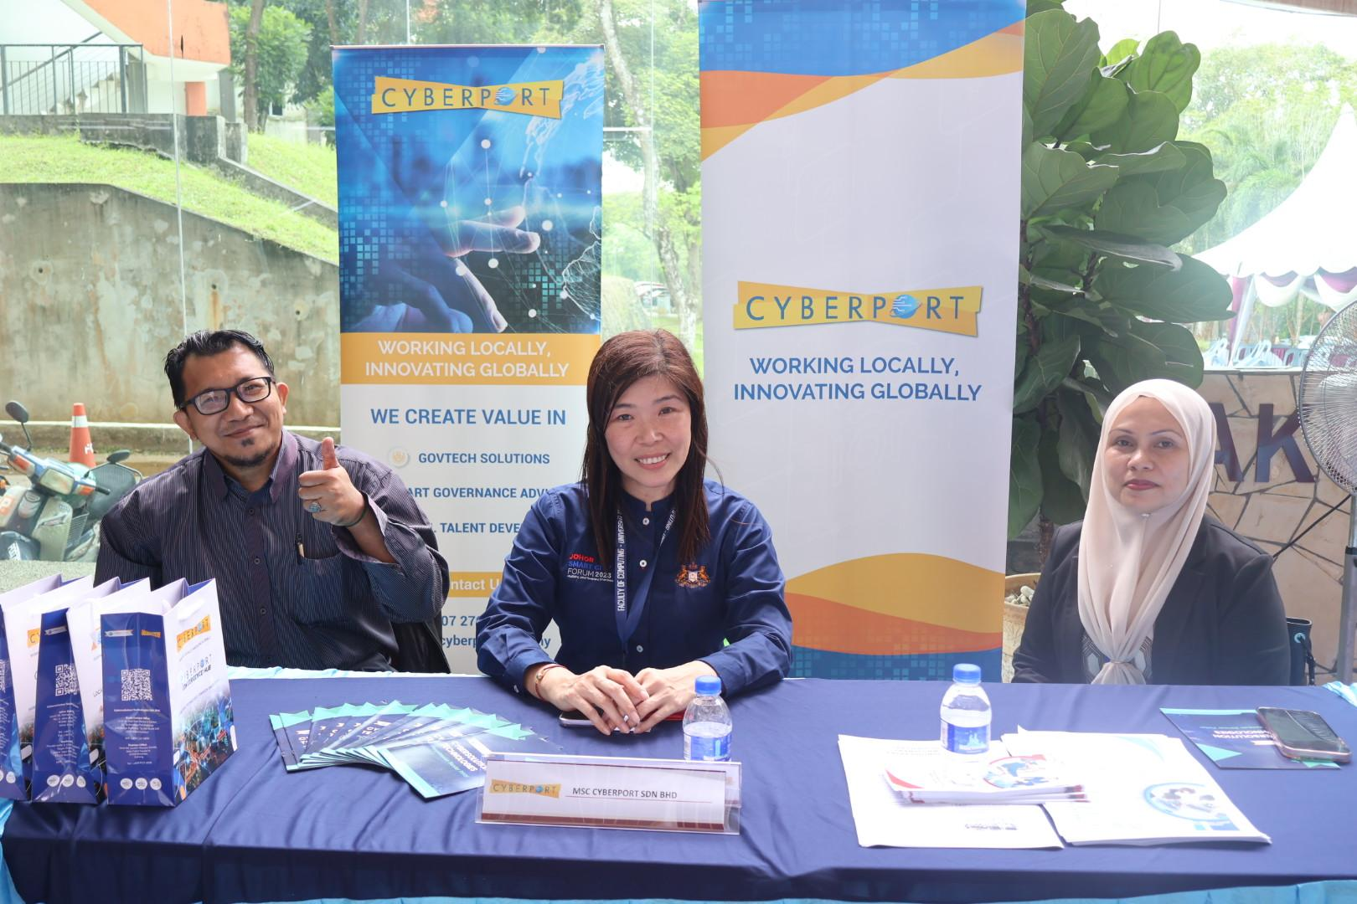MSC Cyberport Sdn. Bhd. showcasing their training programmes
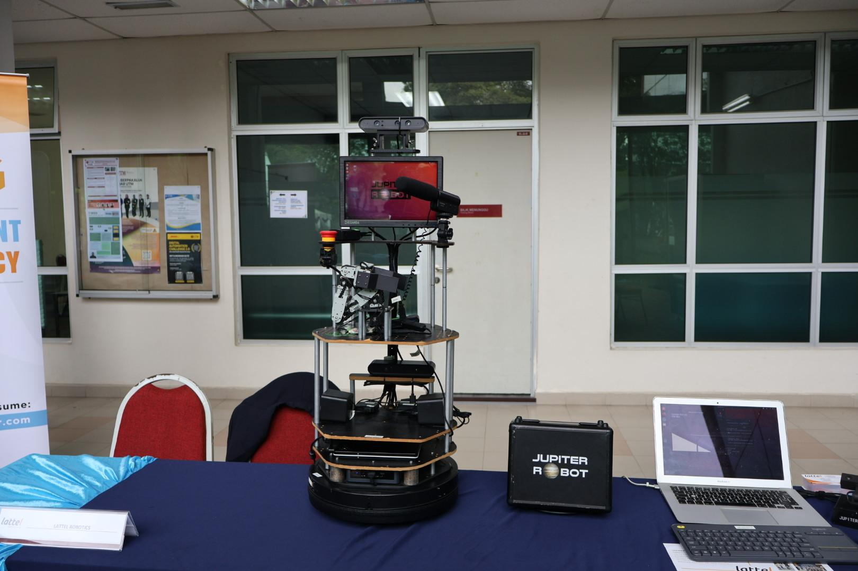
Lattel Robotics showcasing their Jupyter Robot
Challenge:
Throughout our involvement in the Technopreneurship Seminar and Showcase, there were a number of obstacles which were encountered by our technical team that put our coordination and endurance to test. It was challenging to handle different tasks with strict time limitations, more so, when the duties overlapped, such as AV installation and booth assistance. Being a team player meant that we had to keep adjusting and working with one another especially when we experienced some unexpected problems. Interaction with other organizing teams proved to be a difficulty too, as sometimes unclear directions led to delays. Nonetheless, we were able to pull together to get over these challenges and make the event a success, and ran it smoothly. But after all, we were able to get past all these problems and help to succeed overall with the event.
Conclusion:
FCRI Day 2025 was a dynamic and successful event that facilitated cooperation among academia and industry and brought forth the best trends in Cloud Computing, Network Telecommunication, Human Resources development, and Artificial Intelligence. The event was held at the Faculty of Computing, UTM, and featured an integrated blend of professional know-how, technological exhibition, and career development. Attendees could engage on a one-to-one basis with experts, discover advanced AI applications such as autonomous robotics and smart recruitment tools, and familiarize themselves with upskilling programs relevant to Industry 4.0.
More than just a seminar, FCRI Day served as a bridge between students and real industry practices, allowing them to understand the needs of the digital workforce and prepare them for the evolving job market. The event successfully created a platform of knowledge-sharing for the participants to network, learn, and envision their future roles in spearheading technological innovation. As digital transformation continues to accelerate, such an event as FCRI Day is vital in cultivating future-capable talents and propelling Malaysia forward in the global technology landscape.

Appendix
